DESIGN AND ANALYSIS OF ALGORITHM

NAME:G.Ragavendar
ROLL NO: CH.SC.U4CSE24260
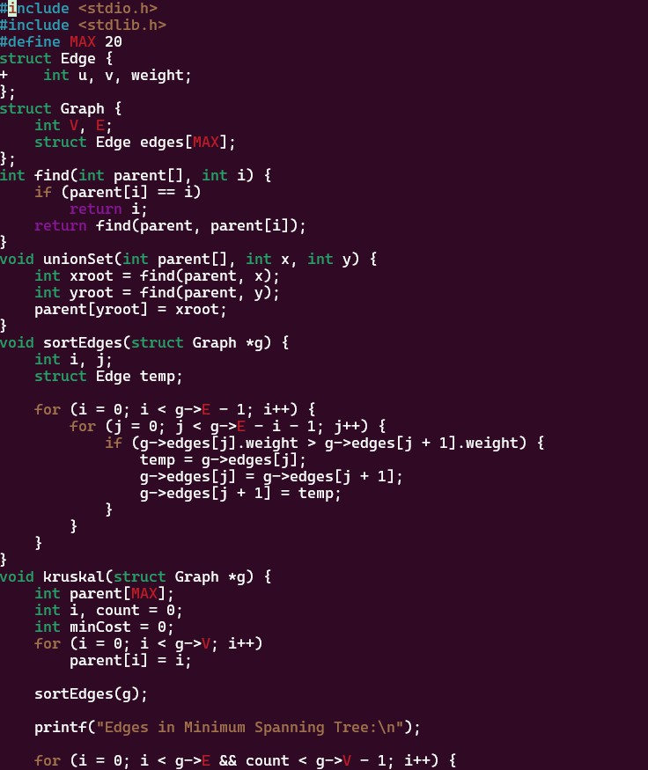
- Kruskel algorithm Code:

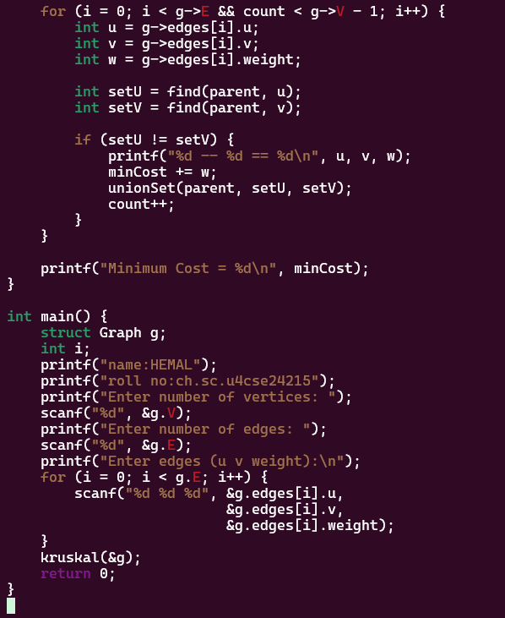

Output:

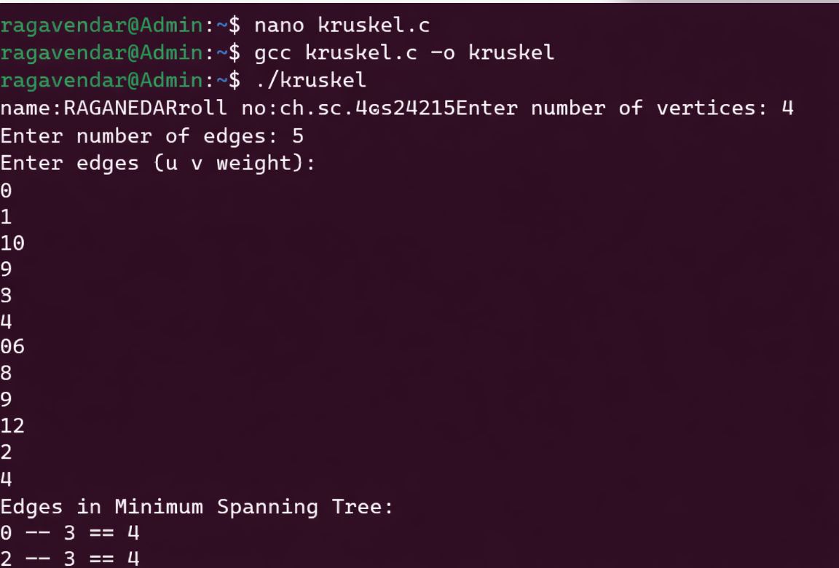

Kruskal’s algorithm is a greedy method used to find the minimum spanning tree of a weighted, undirected graph. It selects edges in increasing order of weight and adds them
only if they do not form a cycle. This process continues until all vertices are connected with minimum total cost.

- prims algorithm Code:
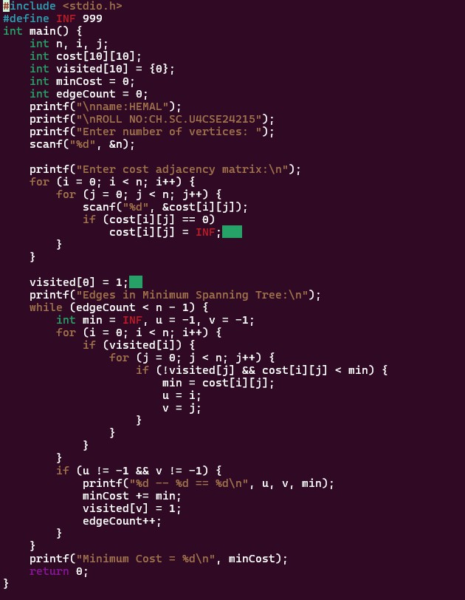
Output:

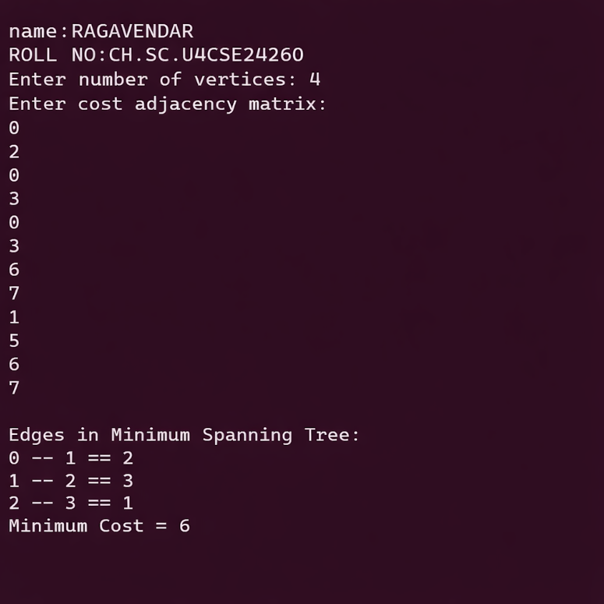Prim’s Algorithm is a greedy algorithm used to find the
minimum Spanning Tree of a weighted, undirected graph. It starts from a chosen vertex and repeatedly selects the
minimum-weight edge that connects a visited vertex to an unvisited vertex, until all vertices are included with minimum total cost.

